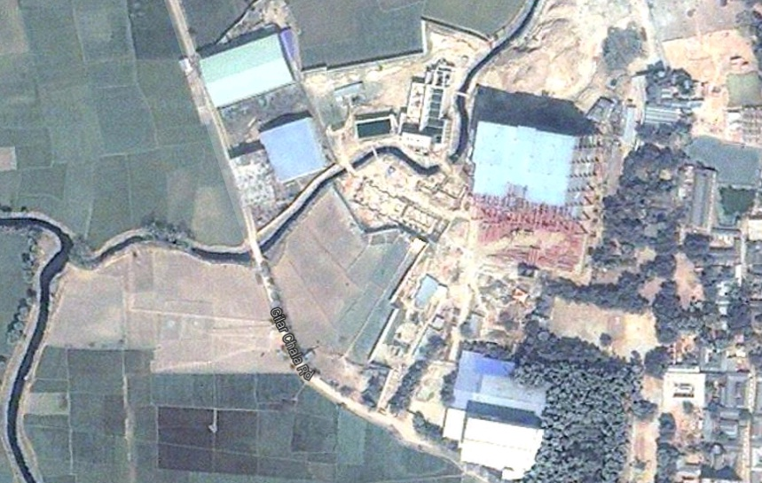
Company Profile
PRODUCTS
NITOCOTE ET402 : 2,250 Ltr.
THIOFLEX 600 : 320 Ltr.
NITOFILL EPLV : 135 Ltr.
DTML SITE

DIGNITY TEXTILE MILLS LTD.
Sreepur, GAZIPUR, bANGLADESH.

etp Protective coating

CLIENT : DIGNITY TEXTILE MILLS LTD.
coNSULTANT : SJP CONSULTING ENGINEERS LTD.
CONTRACTOR : SINAMM ENGINEERING LTD.
APPLICATOR : NUTECH CONSTUCTION CHEMICALs CO. LTD.

Sector : Industry / Textlies

capacity : 5,000 m³/min

surface area : 6,000 sqm

Year : 2014
CASE STUDY
Dignity textile mills ltd. (DTML) is a concerned project of Compagnie Mauricienne de Textile Ltée, a Mauritius Conglomerate. Compagnie Mauricienne de Textile Ltée (CMT), a global jerseywear apparel industry leader, is headquartered in Mauritius with marketing offices in UK, France and New York.
The Project
DTML has built an Effluent Treatment Plant (ETP) at its site to process the textile’s waste water. There are three chambers of it, two sedimentation tanks and one homogenising tank. But from the 1st day of installation it’s facing difficulties on leaking on the construction joints. So, they were asking for a complete solution on sealing those construction joint cracks and expansion joints. Then we involved in there and tried to convince them to have a protective lining on inner side of the ETP, so that the concrete and the reinforcement of the wall may not get wounded on high toxic chemicals, which it will accommodate.
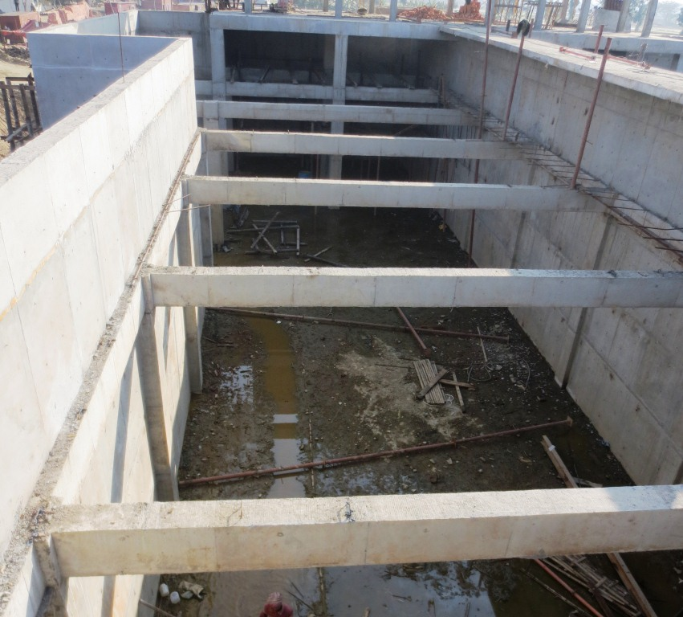
The Solution
Cracks on construction joint were 350 microns to 500 microns. To fill the cracks from inside a low viscous epoxy resin was required; therefore Nitofill EPLV was injected through the construction joint by sealing the outer face and the inner face with Nitobond PC40. Expansion joint size was 40mm X 25mm. To fill the expansion joints Thiofex 600 was applied. Then whole surface was grinded with mechanical grinder to have a uniform, smooth surface for protective coating. Nitocote ET402 was selected for Protective lining on the inner wall, as it acts as an impermeable waterproofing coating and can endure abrasion & chemical resistance from aggressive environments. As it was primer less coating, it proves to be cost effective. Being solvent free was additional benefit for the applicators.
Sedimentation Tank before application
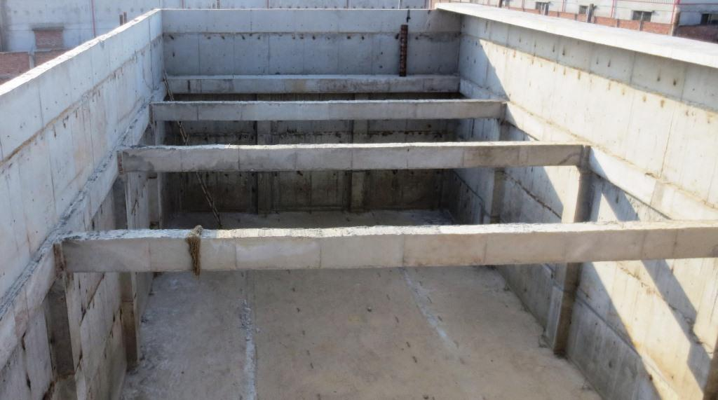
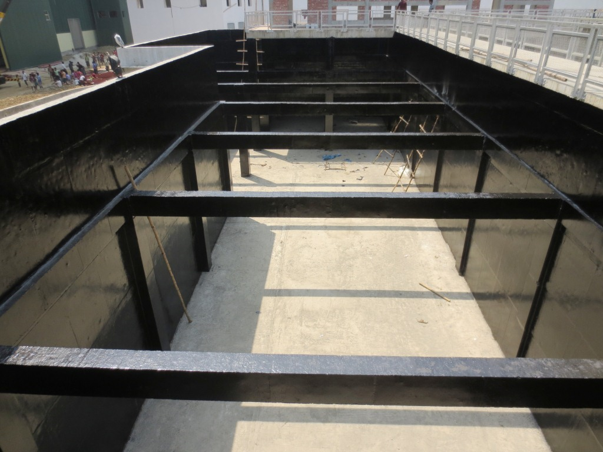
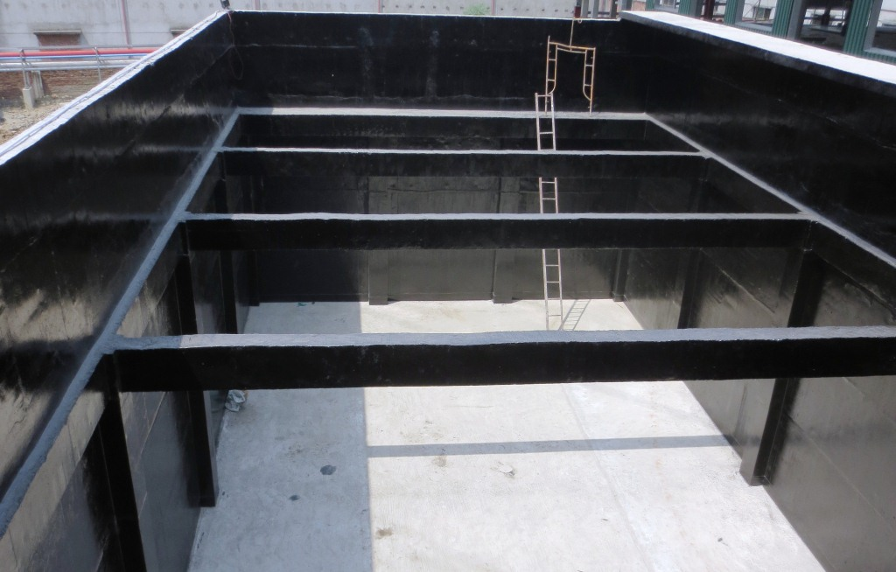
Sedimentation Tank after application
Homogenising Tank before application
Homogenising Tank after application
Application is going on. Wall has been finished. Floor is being prepared to apply Nitocote ET402.

